|  |  |
| --- | --- |
| Course Name | ITD-2313 Script Programming |
| Instructor | G. Morris |
| Student Name | Zane Fanelli |
| Due date | 3/10/2024 |
| Grade | <grade earned here> |
| Grading Comments | <instructor comments here> |

Scripting Projects Week 9

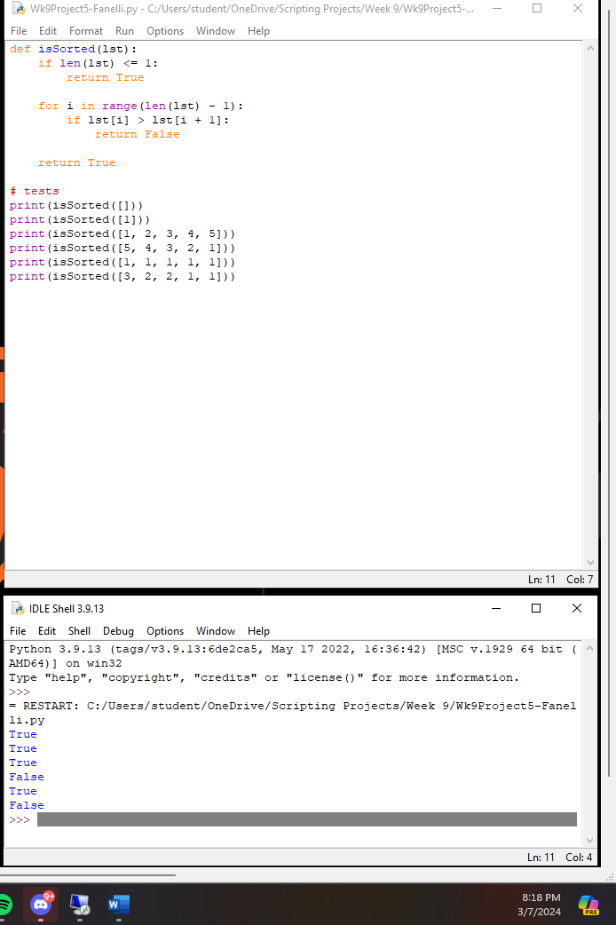Project 5

Project 8

Lee’s code will work as intended, but may eventually reach a Recursion error. The code is not very efficient and will take large amounts of memory to run.

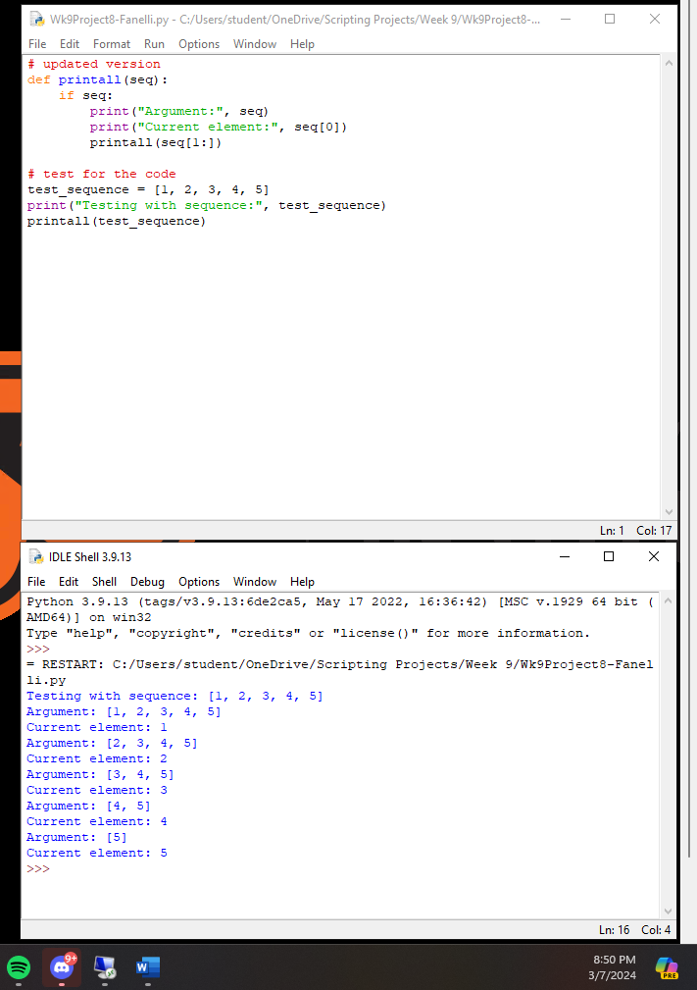

Project 9